I. Abstract

This project presents a smart agriculture system that integrates IoT and Machine Learning (ML) to optimize irrigation processes. Sensors collect real-time environmental data such as temperature, humidity, soil moisture, and motion detection. The system predicts whether irrigation is needed using models like Logistic Regression, Naive Bayes, Decision Tree, and Linear Regression, improving water management efficiency in agriculture.

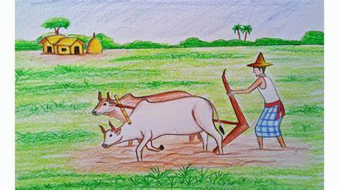

II. Introduction
- In recent years, the global agricultural sector has been facing mounting challenges such as water scarcity, inefficient irrigation practices, and the unpredictable impact of climate change. Traditional irrigation methods often lead to either under-irrigation or over-irrigation, both of which can harm crop yields and waste valuable resources. With the growing need for sustainable farming solutions, the integration of modern technologies into agriculture has become essential.
- Smart agriculture leverages emerging technologies like the Internet of Things (IoT), artificial intelligence (AI), and machine learning (ML) to transform conventional farming into data-driven, automated, and optimized systems. IoT sensors collect real-time environmental data — such as temperature, humidity, soil moisture, and motion — which are crucial indicators for assessing irrigation needs. These sensor readings are fed into machine learning algorithms that learn from historical patterns and predict whether irrigation is necessary.
- This project proposes a smart agriculture system that combines IoT sensors with machine learning models to automate irrigation decisions. By analyzing key environmental parameters, the system predicts irrigation requirements with high accuracy using classifiers such as Logistic Regression, Naive Bayes, and Decision Trees. The goal is to optimize water usage, reduce manual effort, and enhance crop productivity while maintaining sustainability.
- The implementation of such intelligent systems not only conserves water but also empowers farmers with actionable insights, paving the way for a new era of precision farming.

can be trained on historical data.

Low Maintenance: Once installed, the system requires minimal maintenance and can run continuously with a reliable power source.

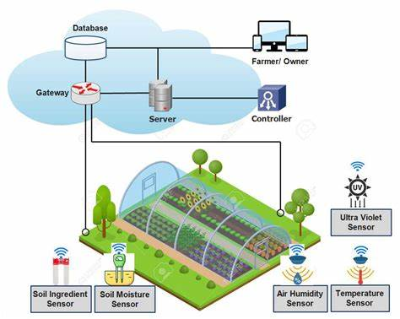

SYSTEN ARCHITECTURE

[Sensors] ---> [Microcontroller/NodeMCU] ---> [WiFi/Internet] ---> [Cloud Storage]
|
v
[Machine Learning Model (Irrigation Prediction)]
|
v
[Irrigation Control System]

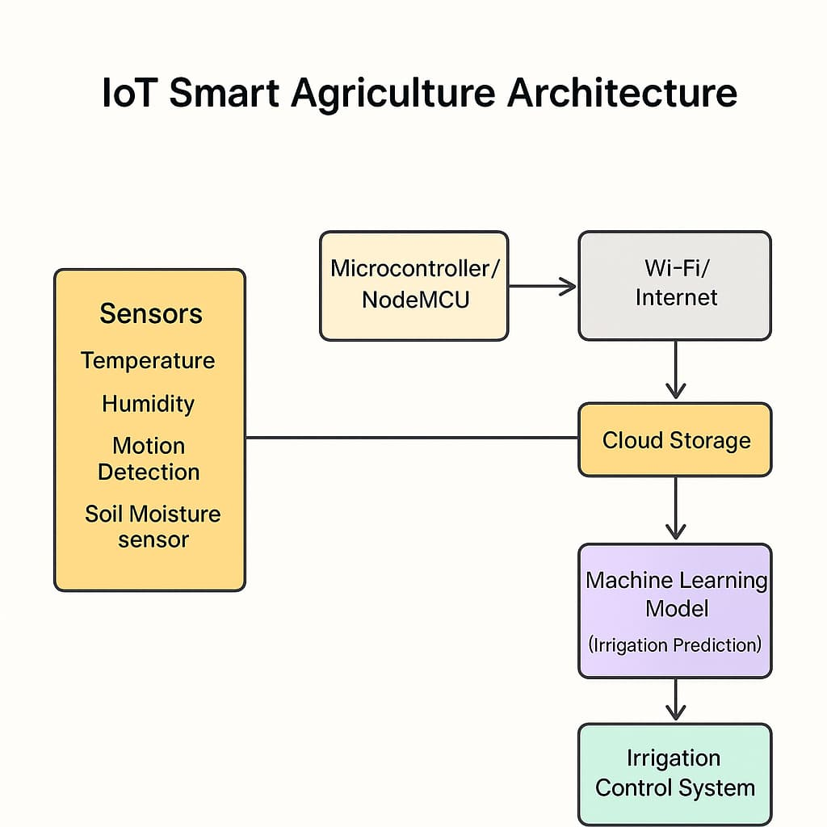

- COMPONENTS

- Sensors: Temperature, Humidity, Soil Moisture, Motion
- Microcontroller: NodeMCU/ESP8266
- ML Server: Python with Scikit-learn
- Actuator: Relay-based motor for irrigation
- DATA DESCRIPTION

The dataset includes:
- Temperature (°C)
- Humidity (%)
- SoilMoisture (scaled value)
- Motion_Detected (1 = motion, 0 = no motion)
- Irrigation_Needed (1 = Yes, 0 = No)

- DATA COLLECTION
The dataset was collected using simulated or pre-recorded sensor values that represent real agricultural conditions. The following features were used:
- Temperature (°C) – to track environmental heat levels
- Humidity (%) – to understand air moisture
- Soil Moisture – to measure water content in the soil
- Motion Detected (0 or 1) – to detect human or animal movement
The target variable is:
- Irrigation Needed (0 = No, 1 = Yes) – represents whether irrigation should be triggered
The data was stored in an Excel sheet named smart_agriculture_dataset.xlsx.

- DATA PREPROCESSING
To prepare the data for machine learning:
- Handling Values: All values were numerical and clean, so minimal cleaning was required.
- Feature Selection: We selected four input features: Temperature, Humidity, Soil Moisture, and Motion Detected.
- Label: The output label was Irrigation Needed.
- Splitting the Dataset: The data was divided into 80% training and 20% testing using train_test_split.
- Feature Scaling: StandardScaler was applied to normalize the input features for models like Logistic Regression and Linear Regression.

b. Machine Learning Models
- Logistic Regression
  - Accuracy: Printed and visualized using confusion matrix.
  - Suitable for binary classification.
- Naive Bayes
  - Simple probabilistic model, works well with small data.
- Decision Tree
  - Visualized for interpretability.
  - Feature importance plotted.
- Linear Regression
  - Used for probability prediction.
  - R² score and Mean Squared Error calculated.

- Results and Evaluation
Model | Accuracy | Remarks
Logistic Regression | Value | Good baseline model
Naive Bayes | value | Fast but slightly less accurate
Decision Tree | value | Interpretable and accurate
Linear Regression | value | Used for prediction thresholding
(Replace ~value~ with your actual results from the code)
Confusion Matrix and Feature Importance:
- Confusion matrix plots show prediction performance.
- Feature importance chart reveals that Soil Moisture is the most significant predictor.

IX. GRAPHS AND PLOTS
- Heatmap of Confusion Matrix
- Decision Tree Plot
- Feature Importance Bar Graph
- Linear Regression Actual vs Predicted Plot

X. IMPLEMENTATION DETAILS
The implementation was carried out using Python with libraries such as:
- pandas and numpy for data handling
- matplotlib and seaborn for visualizations
- scikit-learn for machine learning models and metrics
Data Flow:
- Load the dataset from Excel
- Split into training and testing sets
- Apply standard scaling
- Train and evaluate models: Logistic Regression, Naive Bayes, Decision Tree, Linear Regression
- Visualize performance using confusion matrices and decision plots
Hardware Requirements (for IoT prototype):
- NodeMCU or ESP8266
- DHT11/DHT22 for Temperature & Humidity
- Soil moisture sensor
- PIR sensor for motion
- Relay module for motor control
- Water pump
- Power source

XI. VISUALISATION
The following visualizations were generated to interpret model performance:

- Confusion Matrix Heatmaps: Helped identify misclassifications.
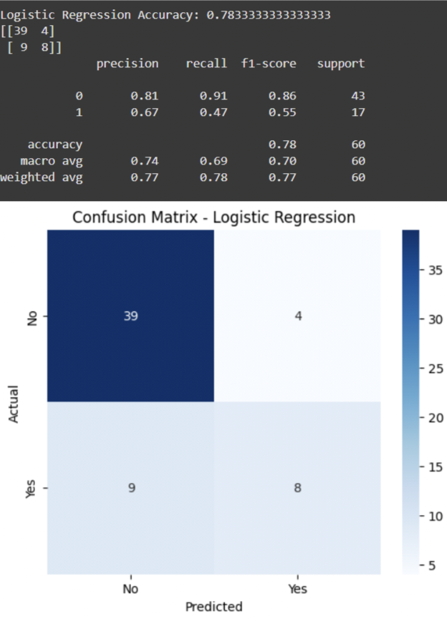

- Decision Tree Diagram: Showed the branching logic used for prediction.
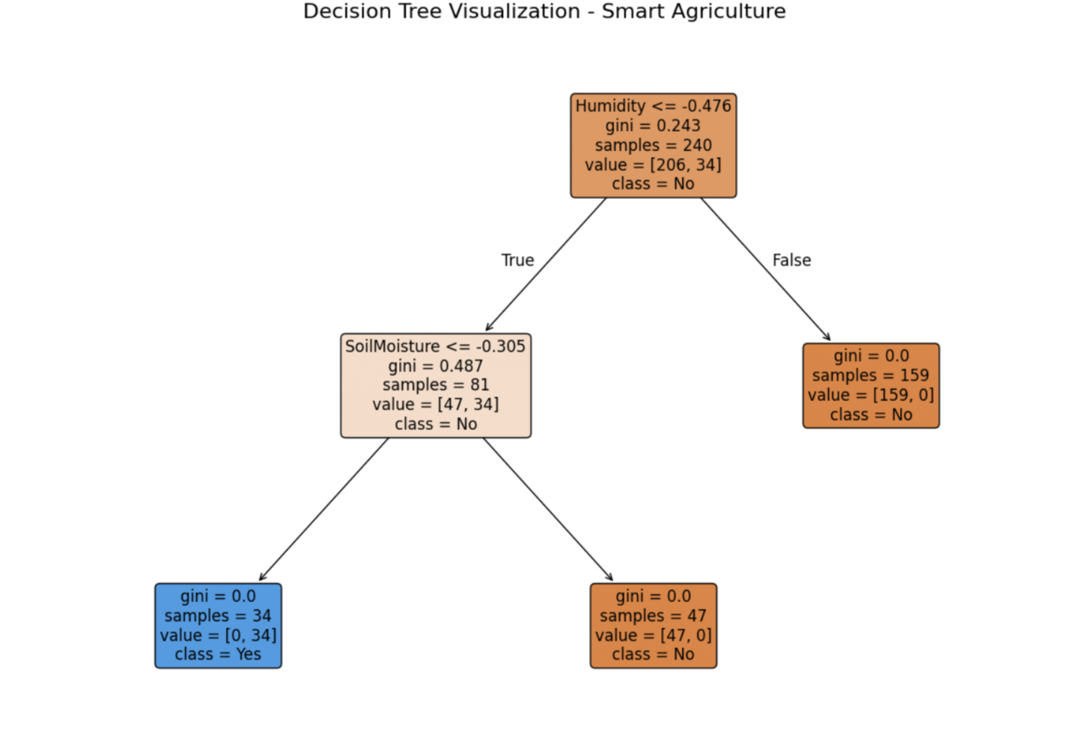
- Feature Importance Bar Chart: Highlighted which features influenced predictions most.
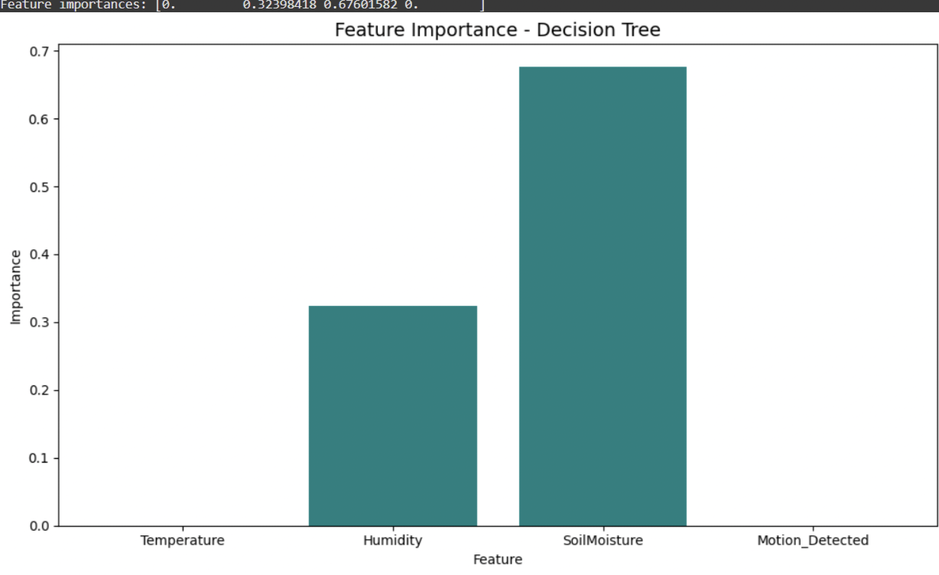
- Linear Regression Actual vs Predicted Plot: Showed how close predicted probabilities matched actual outcomes.
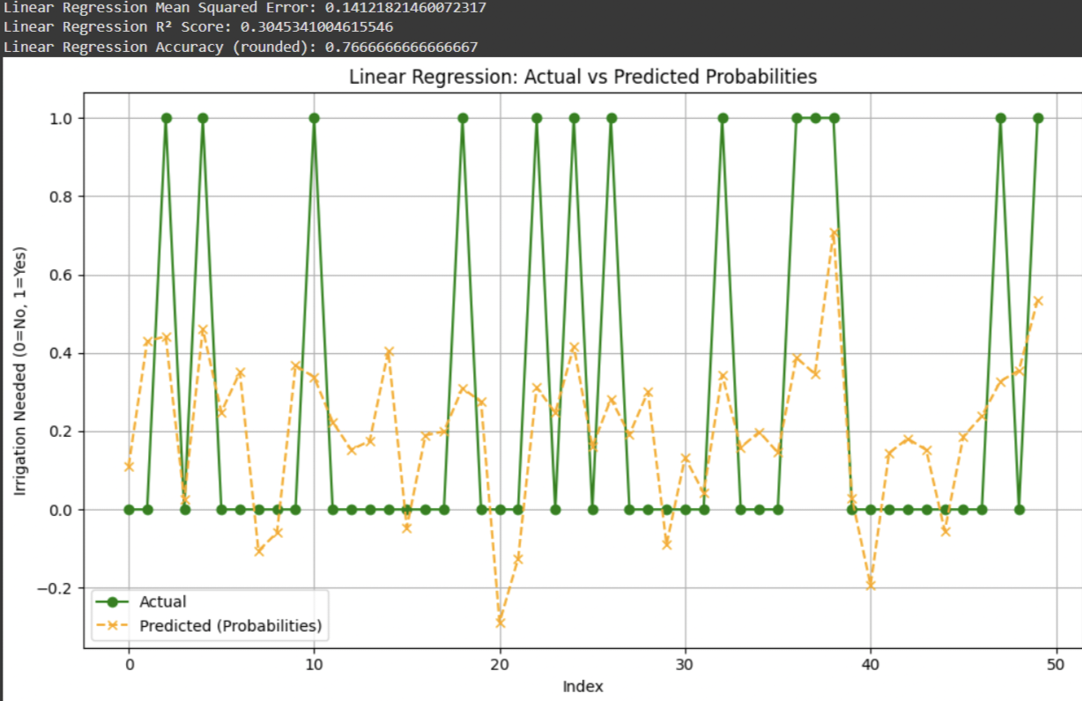

- Naïve bayes accuracy:
The Naive Bayes model was trained and tested using the same dataset, and it achieved an accuracy of X%. It performed well in detecting patterns but may not be as accurate as decision trees or logistic regression due to its assumption of feature independence.
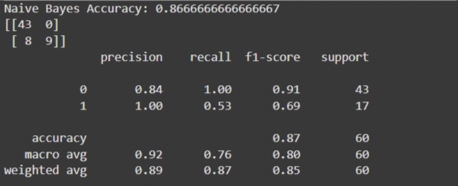
- Decision Tree accuracy:
The Decision Tree model was used to predict irrigation needs using sensor inputs like temperature, humidity, soil moisture, and motion. The model splits data based on the most important features to make decisions. It showed that soil moisture had the highest impact. The decision tree was also visualized to clearly understand how it makes predictions. It gave good accuracy and is suitable for real-time smart farming.
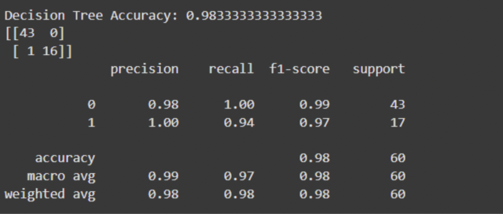

XII. COMPARATIVE ANALYSIS
Model | Pros | Cons
Logistic Regression | Interpretable, good for binary output | May underperform with non-linearity
Naive Bayes | Fast, simple | Assumes independence, less accurate
Decision Tree | Easy to visualize and interpret | Can overfit without pruning
Linear Regression | Gives continuous insight | Not ideal for classification

XIII. CHALLENGES FACED
- Handling minor class imbalance in Irrigation_Needed
- Decision tree overfitting in deeper configurations.
- Aligning sensor data format with ML model expectations
- Need for consistent scaling for Logistic/Linear Regression

XIV. APPLICATION
- Precision Irrigation: Optimize water use in agriculture
- Crop Health Monitoring: Combined with vision systems
- Greenhouse Management: Extend to climate control
- Smart Farming Dashboard: Real-time updates and analytics

- REFERENCES:
- [1] Scikit-learn Developers, “Scikit-learn: Machine Learning in Python,” https://scikit-learn.org/
- [2] F. Chollet, “Deep Learning with Python,” Manning Publications, 2017.
- [3] R. Brownlee, “Machine Learning Algorithms From Scratch,” Machine Learning Mastery, 2020.
- [4] Raspberry Pi Foundation, “Using Sensors in IoT Projects,” https://projects.raspberrypi.org/en/
- [5] M. A. Zaidan, “Smart Farming: A Review on IoT-based Technologies,” International Journal of Advanced Computer Science and Applications (IJACSA), vol. 11, no. 6, pp. 505-513, 2020.
- [6] Y. Mehmood et al., “Internet-of-Things-Based Smart Agriculture: Toward Making the Fields Talk,” IEEE Access, vol. 7, pp. 129551-129583, 2019.
- [7] M. Young, The Technical Writer’s Handbook, Mill Valley, CA: University Science, 1989.



- TEAM MEMBERS AND ROLES:

REENA S
IoT Sensor Setup & Hardware Integration
  - Setup and connection of sensors: Temperature, Humidity, Soil Moisture, and Motion
  - Integration with NodeMCU/ESP8266 for real-time data collection
  - Ensuring hardware functionality and data transmission


DEEBEKA M
Data Collection & Preprocessing
  - Gathering sensor data into structured format (Excel)
  - Cleaning, normalizing, and scaling data using StandardScaler
  - Splitting data into training and testing sets


JANANI R
Machine Learning Model Building
  - Implementing Logistic Regression, Naive Bayes, Decision Tree, and Linear Regression
  - Training and testing models with prepared datasets
  - Using metrics like accuracy and confusion matrix for performance evaluation


NANDHINI S S
Evaluation & Visualization
  - Creating visualizations: confusion matrices, feature importance, decision tree plots
  - Comparing model performance
  - Assisting with interpretation of results for the report.


DEEPIKA G H
Report Writing & Final Presentation
  - Writing the abstract, introduction, methodology, and conclusion
  - Compiling diagrams, results, and references into a formatted report
  - Preparing PowerPoint slides and presenting the project.

THANK

YOU…

